**Circuit and System-I Lab**

**LAB # 11**



**Spring 2022**

Submitted by: Muhammad Sudais Bin Sohail

Registration No.: **21PWCSE2077**

Class Section: **C**

“On my honor, as student of University of Engineering and Technology, I have neither given nor received unauthorized assistance on this academic work.”

Student Signature: ______________

Submitted to:

**Engr. Faiz Ullah**

30 June, 2022

Department of Computer Systems Engineering

**ASSESSMENT RUBRICS LAB # 11**

**Analyzing RC-Circuit using PSpice**

|  |  |  |
| --- | --- | --- |
| **Criteria** | **Excellent** | **Marks Obtained** |
| 1. **Objectives of Lab** | All objectives of lab are properly covered  [Marks 0.5] |  |
| 1. **RC-Circuit** | Brief introduction of RC-Circuit  [Marks 1] |  |
| 1. **PSpice** | Brief introduction about PSpice  [Marks 0.5] |  |
| 1. **Circuit Diagram** | Circuit diagram of RC circuit with proper labeling  [Marks 1] |  |
| 1. **Procedure of PSpice,**   **Graph** | PSpice procedure and steps followed for RC-Circuit settings and to get graph. Simulated graph results are also shown  [Marks 6] |  |
| 1. **Conclusion** | Conclusion about RC-Circuit analysis  [Marks 1] |  |

**TITLE:**

**Analyzing RC-Circuit using PSpice**

**OBJECTIVES:**

* + - * To know about RC Circuit
      * To draw a basic RC Circuit using PSPICE
      * To understand the graph of RC Circuit

**RC Circuit:**

An RC circuit is a circuit with both a resistor (R) and a capacitor (C).

OR

The combination of a pure resistance R in ohms and pure capacitance C in Farads is called RC circuit.

The capacitor store energy and the resistor connect in series with the capacitor control the charging and discharging of a capacitor. RC circuits are frequent element in electronic devices

**Example:**

The RC circuit is used in camera flashes, pacemaker, timing circuit etc.

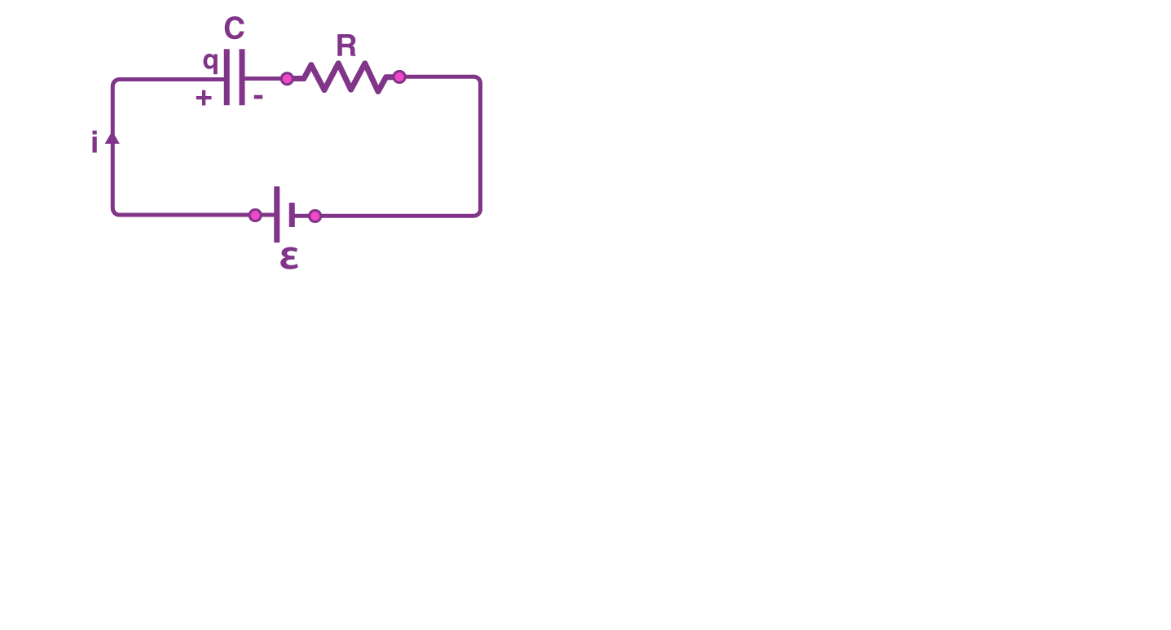

Basic RC Circuit

**pspice:-**

The circuit file contains different functions which makes the work of an engineer more easy. One can put any sort of symbol using this software and can make different types of circuit diagrams.

**RC Circuit using PSPICE:**

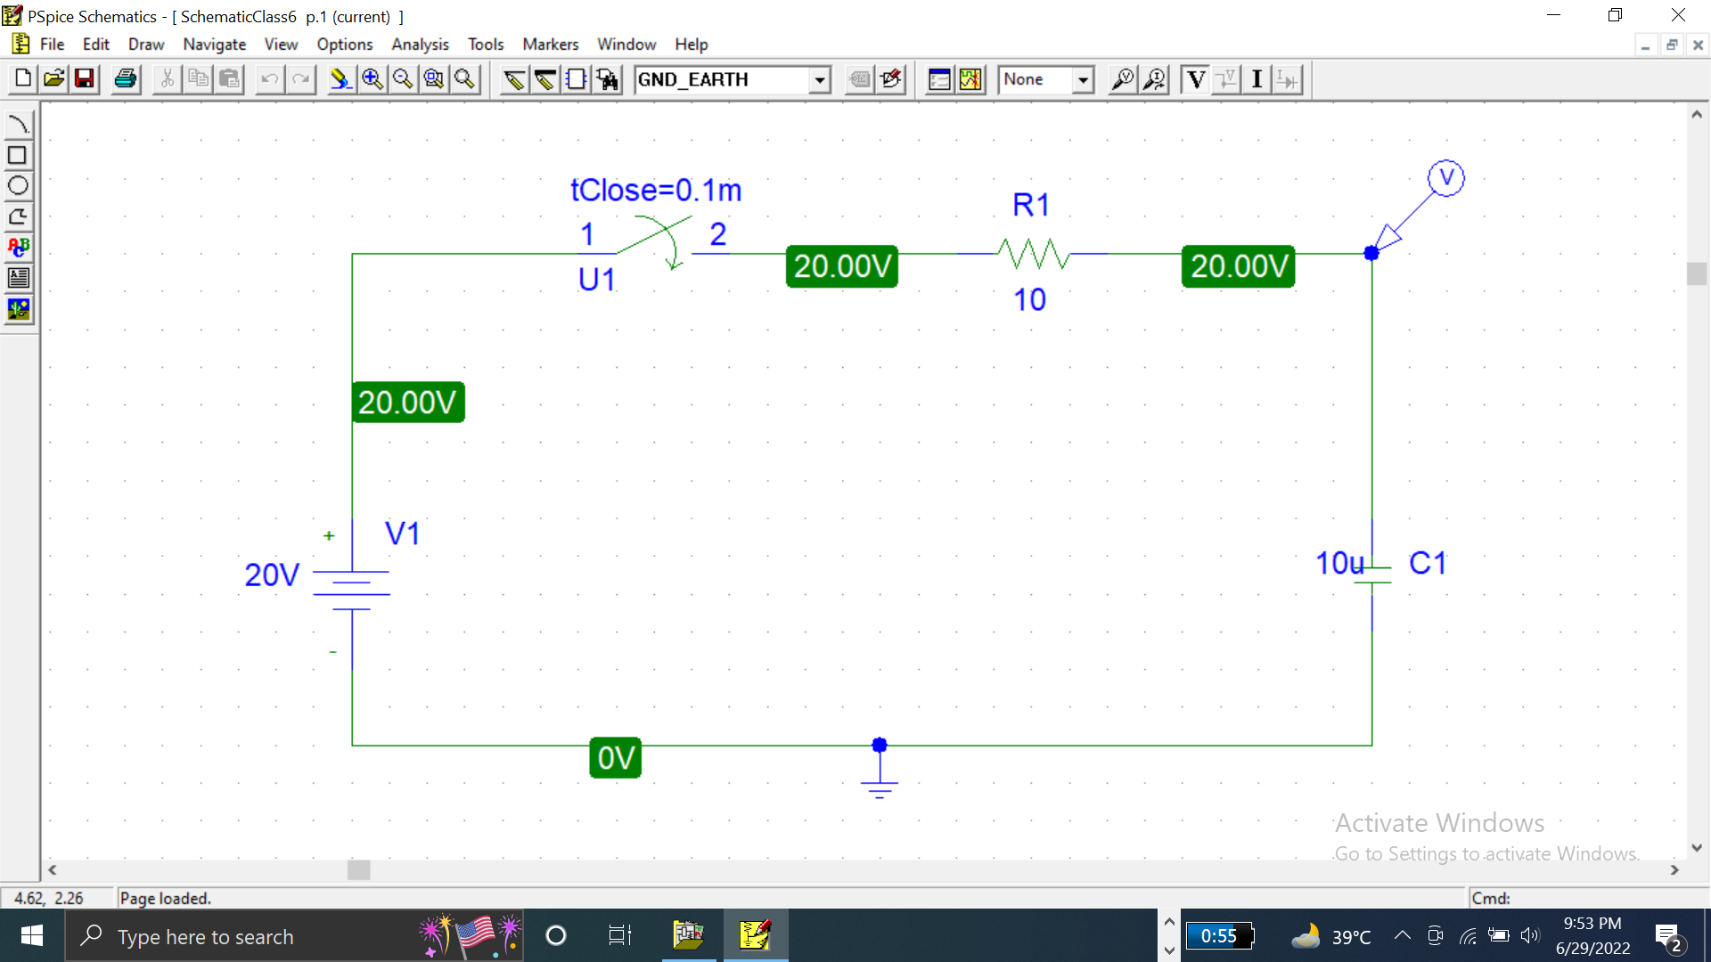

**STEPS:**

* For capacitor use **“C”**
* For switch we use **“sw-tclose”**
* y.PNGfor voltage maker
* Select **“analysis”** from menu bar
* In analysis select **“setup”.**
* In setup.check **“transient”**button.
* Click **transient** button
* Pop window will appear
* Check skip initial transient solution and then click **“ok”**
* Then, simulate graph will appear
* In graph window, there is trace button
* Click on **“Add trace”**
* Click on **I(Ci)**

**GRAPH:**

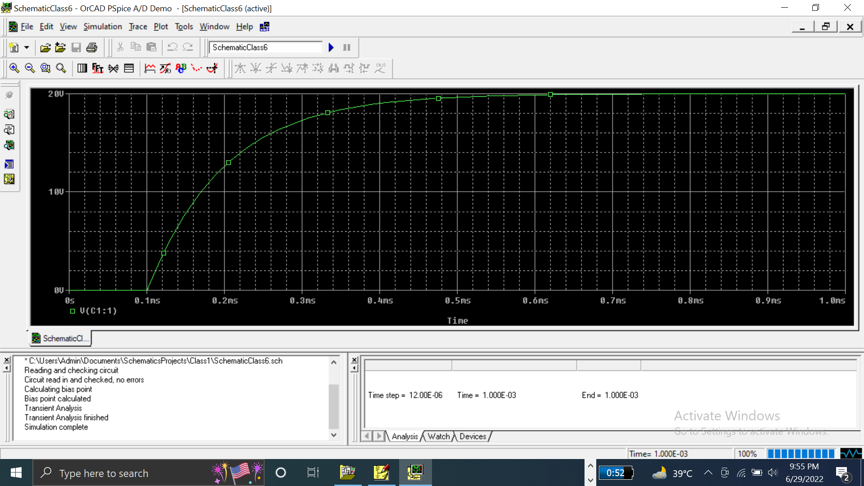

**CONCLUSION**

Like the other network **analysis** procedures, we can use to find out the RC through a particular element or elements using pspice.